Small Retail Survival Agent-Multi-Agent GenAI & Time-Series Decision System for Independent Retailers

Project Description:
Small Retail Survival Agent is a LangGraph-orchestrated multi-agent GenAI and time-series forecasting system that helps independent retailers, such as Kirana stores, boutiques, and cafes, know what to stock, what to clear, and what to promote, without spreadsheets, BI dashboards, or a data team.
The system acts as a centralized AI analyst team. It ingests raw daily point-of-sale sales transaction CSVs and executes a sequential 5-agent state graph with explicit Pydantic state handoffs. It computes sell-through velocity, generates probabilistic 7, 14, and 30-day demand forecasts with automatic sparse-data fallbacks, reasons over inventory lead times versus margins, and formulates a single high-conviction weekly promotional push. The final output is delivered as a plain-language executive action briefing accompanied by an interactive, on-demand explainability Q&A path.
Independent retailers operate largely on intuition, which leads to imminent stockouts on fast-moving staples, dead stock and spoilage that locks up working capital, and unstrategic promotions that ignore margin trade-offs. This system resolves that by transforming raw sales transactions into actionable operational directives, handling dirty or sparse data automatically, assessing supplier lead-time risk, and producing jargon-free recommendations. When a shopkeeper asks "Why did you recommend this?", the Orchestrator queries the stored multi-agent reasoning trace to answer instantly, without re-running the analytical pipeline.

Scenarios
Scenario 1: Royal Basmati Rice 5kg sees a 55% surge in sales velocity while stock falls to 12 bags, about 2.6 days of supply, against a 7-day supplier lead time. The Inventory Strategist Agent flags a critical stockout risk and recommends an immediate reorder of 55 bags, including a safety buffer, before the shelf goes empty.

Scenario 2: Artisanal Organic Paneer 200g has 38 units in stock with only 7 days of shelf life left, while velocity has slowed to 1.5 units/day, or 25 days of inventory. ₹3,724 in working capital is at risk of total spoilage loss. The Strategist and Marketing Advisor flag the hazard and suggest an immediate 20% weekend markdown to liquidate the stock within 48 to 72 hours.

Scenario 3: Grand Reserve Masala Chai 250g carries a 62% gross margin, has healthy stock, and pairs naturally with Butter Biscuits for weekend morning footfall. The Marketing Advisor Agent selects this as the single weekly promotion, "Morning Chai & Biscuit Combo", projecting a 28% volume lift.

Technical Architecture:
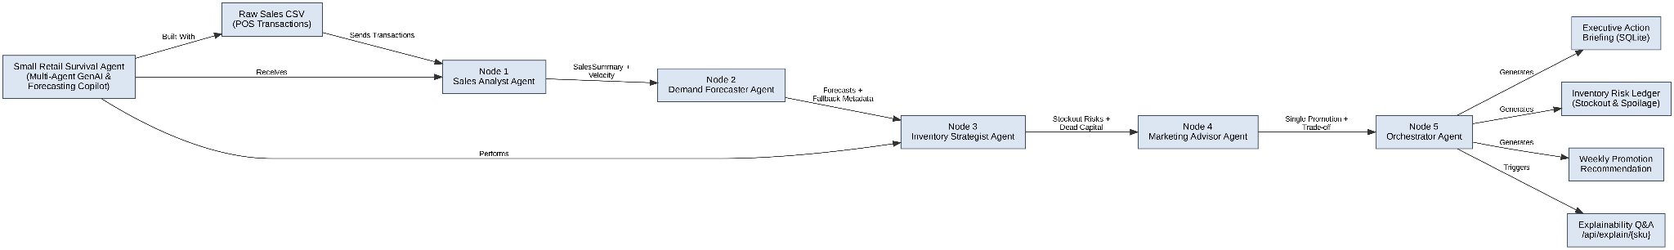

Description: Raw sales CSVs flow into a sequential LangGraph state machine of 5 agent nodes, each reading and extending a shared Pydantic RetailState object. The Sales Analyst computes velocity and seasonality; the Demand Forecaster produces confidence-banded forecasts with an automatic fallback for sparse SKUs; the Inventory Strategist computes safety stock, reorder quantities, and risk flags; the Marketing Advisor picks a single promotional move; and the Orchestrator resolves cross-agent conflicts and compiles the final report into SQLite. A lightweight explainability path answers shop-owner questions directly from the stored state.

Pre-requisites:
Before developing the project, ensure the following software and technologies are available:
- Python 3.10 or higher: https://www.python.org/downloads/
- Node.js v18 or higher: https://nodejs.org/
- npm v9 or higher: https://www.npmjs.com/
- FastAPI: https://fastapi.tiangolo.com/
- Pydantic v2: https://docs.pydantic.dev/
- LangGraph: https://langchain-ai.github.io/langgraph/
- LangChain Groq integration: https://python.langchain.com/docs/integrations/chat/groq/
- statsmodels: https://www.statsmodels.org/
- scikit-learn: https://scikit-learn.org/
- Pandas: https://pandas.pydata.org/
- NumPy: https://numpy.org/
- React 18: https://react.dev/
- Vite: https://vite.dev/
- Tailwind CSS: https://tailwindcss.com/
- Three.js: https://threejs.org/
- Visual Studio Code: https://code.visualstudio.com/
- Git: https://git-scm.com/
- GitHub: https://github.com/
- Groq API key (optional — heuristics work without it): https://console.groq.com/keys

Project Workflow

Milestone 1: Data Foundation and Sales Analyst Agent
Activity 1.1: Define the shared Pydantic RetailState schema and the SQLite persistence layer used to hand off data between all 5 agents.
Activity 1.2: Build the CSV ingestion and cleaning pipeline: validate required columns, drop negative quantities and duplicate rows, and detect date gaps.
Activity 1.3: Implement the Sales Analyst Agent to compute 7d/14d/30d velocity, category revenue share, and weekend/salary-cycle seasonality.

Milestone 2: Demand Forecasting Engine

Activity 2.1: Implement the Demand Forecaster Agent using Statsmodels ETS (Holt-Winters) or Ridge lag regression for SKUs with 8 or more weeks of history.

Activity 2.2: Implement the automatic sparse-data fallback: a category momentum moving-average heuristic for newly launched or low-history SKUs.

Milestone 3: Inventory Strategist Agent

Activity 3.1: Compute dynamic safety stock (Z·√L·σd), reorder points, and suggested reorder quantities.

Activity 3.2: Flag critical stockout cliffs (days of supply ≤ lead time) and perishable spoilage hazards, and quantify capital at risk.

Milestone 4: Marketing Advisor and Orchestrator

Activity 4.1: Implement the Marketing Advisor Agent to select exactly one high-conviction promotional move (bundle, markdown, or volume tier).

Activity 4.2: Implement the Orchestrator Agent to resolve cross-agent conflicts and compile the executive report.

Activity 4.3: Wire all 5 agents into the LangGraph StateGraph with sequential edges.

Milestone 5: Explainability and API Layer

Activity 5.1: Build the FastAPI REST routes for health, SKUs, synthetic seeding, CSV upload, and analysis.

Activity 5.2: Build the Server-Sent Events endpoint that streams each agent step as the pipeline runs.

Activity 5.3: Build the /api/explain/{sku} explainability endpoint and the freeform /api/chat endpoint.

Milestone 6: Frontend Dashboard

Activity 6.1: Set up the dark Kirana theme in Tailwind: background, panel, amber accent, and sage muted-text tokens, with Fraunces and Inter fonts.

Activity 6.2: Build the Monday Morning Action Briefing dashboard, the inventory risk ledger, and the marketing pick page.

Activity 6.3: Build the 3D Kirana shelf visualization in Three.js and the live agent pipeline stream view.

Milestone 7: Testing, Documentation and Reporting

Activity 7.1: Validate the 3 engineered showcase scenarios (stockout, spoilage, promotion pick) with automated tests.

Activity 7.2: Document design decisions and identify future enhancements.

Milestone 8: Conclusion

Milestone 1: Data Foundation and Sales Analyst Agent
This milestone builds the shared state model, ingests raw POS data, and produces the first analytical layer: sell-through velocity and seasonality per SKU.

Activity 1.1: Shared State Schema and Database
Define Pydantic models for SalesSummary, ForecastReport, StrategistOutput, MarketingOutput, and the overarching RetailState that every agent node reads and extends.
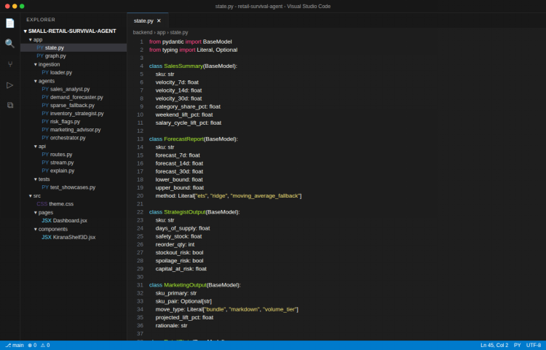
Description: The screenshot shows the RetailState schema and its nested Pydantic models, which form the explicit handoff contract between all 5 agents.

Activity 1.2: CSV Ingestion and Cleaning
Load the raw transaction CSV, validate required columns (date, sku, category, units_sold, unit_price, stock_on_hand), drop negative quantities and duplicate rows, and detect gaps in the date range.

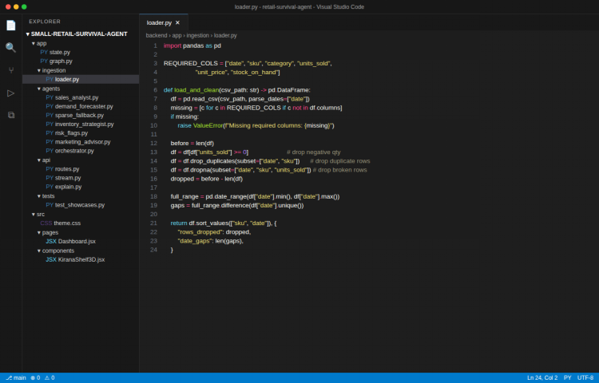

Description: The screenshot shows the ingestion function that cleans a raw sales CSV and reports how many rows were dropped and how many date gaps were found.

Activity 1.3: Sales Analyst Agent
Compute 7d/14d/30d rolling sell-through velocity per SKU, each SKU's share of category revenue, and weekend and salary-cycle demand lift relative to weekday baseline.
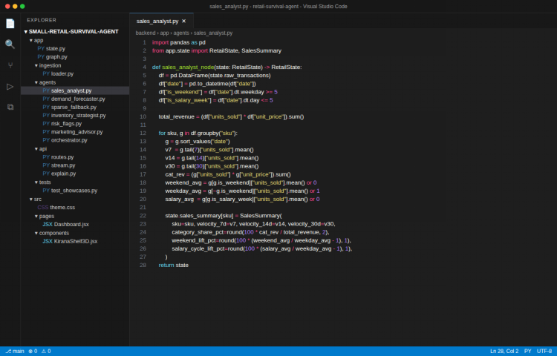

Description: The screenshot shows the Sales Analyst node populating a SalesSummary for every SKU in the dataset from the cleaned transaction history.

Milestone 2: Demand Forecasting Engine
This milestone implements the agent that turns historical velocity into forward-looking 7, 14, and 30-day demand forecasts, with confidence bands and an automatic fallback for new or sparse SKUs.

Activity 2.1: ETS and Ridge Forecasting for Rich SKUs
For SKUs with 8 or more weeks of history, fit a Holt-Winters exponential smoothing model (or a Ridge lag-regression model as a secondary method) and derive 7/14/30-day point forecasts with upper and lower confidence bounds.
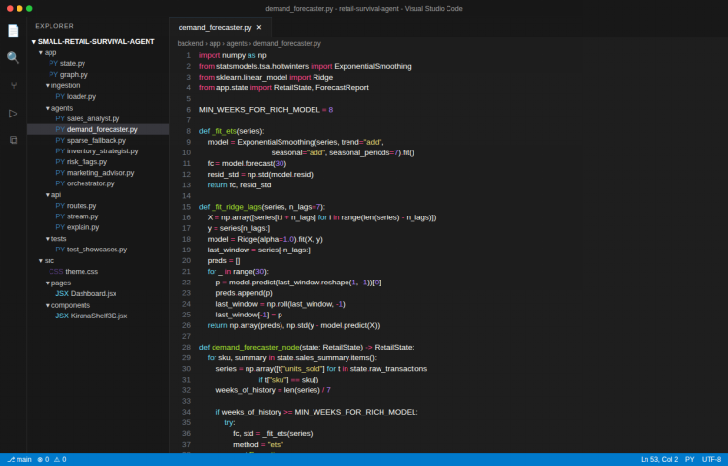

Description: The screenshot shows the forecaster choosing between ETS and Ridge regression based on data richness and producing a ForecastReport with confidence bounds.

Activity 2.2: Sparse-Data Fallback Heuristic
For newly launched or low-history SKUs, blend the SKU's own limited history with its category's average velocity into a momentum estimate, with a wider confidence band to reflect lower certainty.
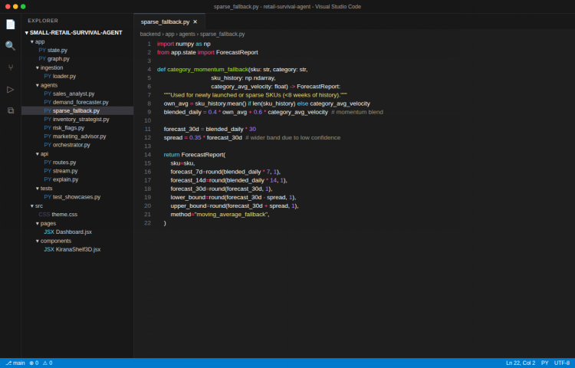

Description: The screenshot shows the category momentum fallback function used automatically when a SKU does not have enough history for the richer models.

Milestone 3: Inventory Strategist Agent
This milestone reasons over lead time, margin, and shelf life to produce concrete reorder and risk-flag decisions for every SKU.

Activity 3.1: Safety Stock and Reorder Quantity
Compute safety stock using Z·√L·σd, derive the reorder point from daily demand and lead time, and calculate the suggested reorder quantity against current stock on hand.

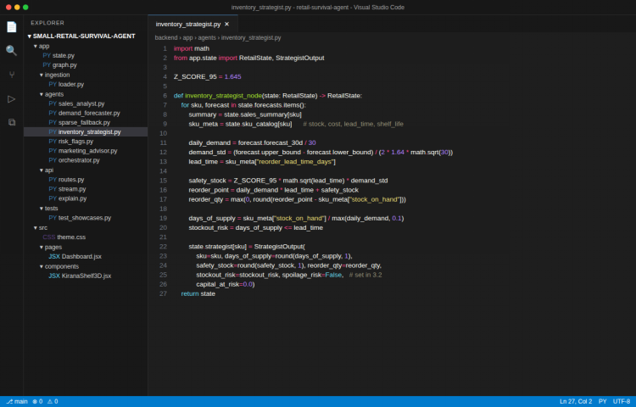
Description: The screenshot shows the safety-stock and reorder-quantity formulas applied per SKU, along with the resulting days-of-supply figure.

Activity 3.2: Stockout and Spoilage Flags
Flag a critical stockout risk when days of supply falls at or below the supplier lead time, and flag a spoilage hazard when a perishable SKU is both slow-moving and close to its shelf-life limit, quantifying the capital at risk.
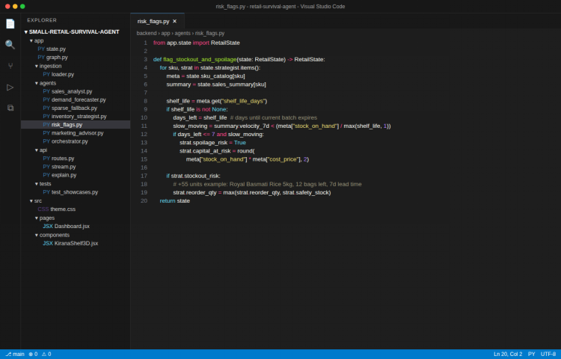

Description: The screenshot shows the risk-flagging logic behind the Basmati Rice stockout catch and the Paneer spoilage catch from the showcase scenarios.

Milestone 4: Marketing Advisor and Orchestrator
This milestone picks a single, high-conviction weekly promotion and resolves any tension between the marketing pick and the inventory risk flags before compiling the final report.

Activity 4.1: Marketing Advisor Agent
Evaluate promotion candidates: spoilage-risk SKUs get a markdown recommendation, and healthy high-margin SKUs get a bundle recommendation with a naturally paired item, then select exactly one move with a plain-language rationale.

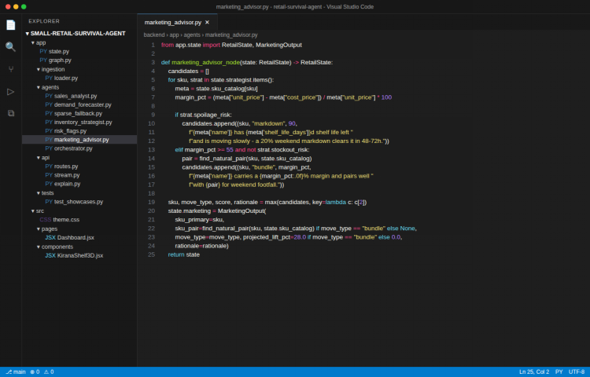
Description: The screenshot shows the Marketing Advisor choosing between a markdown and a bundle candidate and settling on a single recommended move.

Activity 4.2: Orchestrator Conflict Resolution
Veto any marketing pick that targets a SKU already flagged for critical stockout risk, net the reorder capital required against the clearance cash unlocked by markdowns, and compile the final executive report.
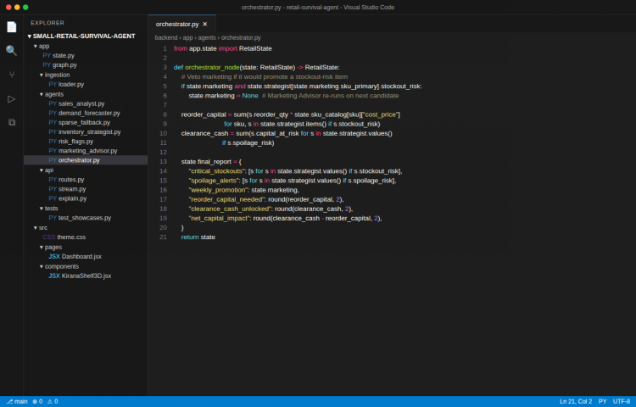
Description: The screenshot shows the Orchestrator's conflict-resolution logic and the compiled final report structure, including net capital impact.

Activity 4.3: LangGraph State Graph Wiring
Connect all 5 agent nodes into a single LangGraph StateGraph with sequential edges from Sales Analyst through to Orchestrator.
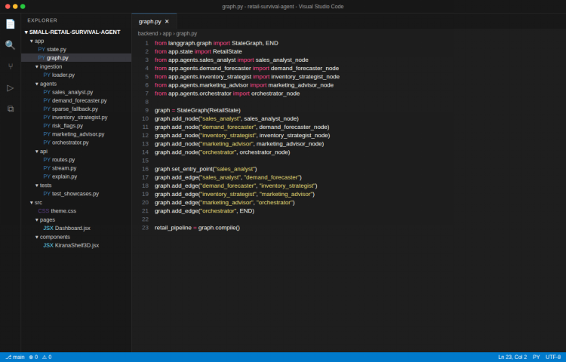

Description: The screenshot shows the LangGraph definition wiring the 5 nodes into the compiled retail_pipeline.

Milestone 5: Explainability and API Layer
This milestone exposes the pipeline over a FastAPI REST and streaming interface, including the on-demand explainability path.

Activity 5.1: FastAPI Routes
Expose endpoints for health check, SKU listing, synthetic data seeding, CSV upload, and synchronous pipeline execution.
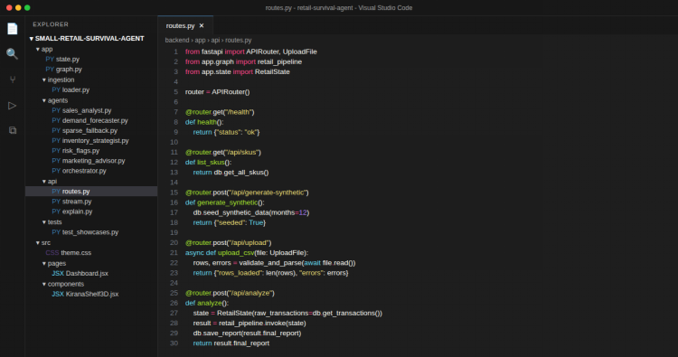
Description: The screenshot shows the core FastAPI router wiring the retail_pipeline into REST endpoints.

Activity 5.2: SSE Streaming Endpoint
Stream each agent's completion as a Server-Sent Event so the frontend can show live pipeline progress instead of waiting for the full run.
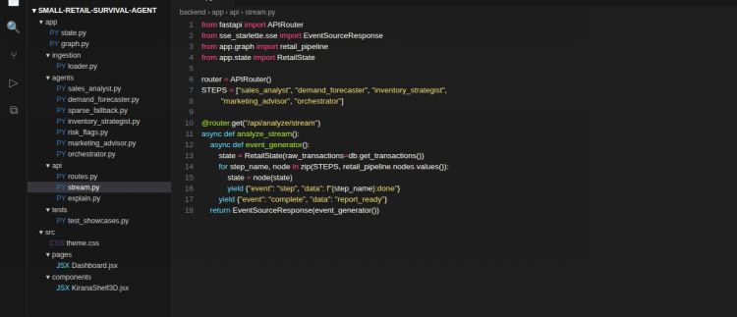
Description: The screenshot shows the /api/analyze/stream endpoint yielding a step event after each of the 5 agent nodes runs.

Activity 5.3: Explainability Q&A Endpoint
Answer "why" questions about a specific SKU directly from the stored state (burn rate, days left, lead time, safety stock) without re-running the pipeline, plus a freeform store-wide chat endpoint.
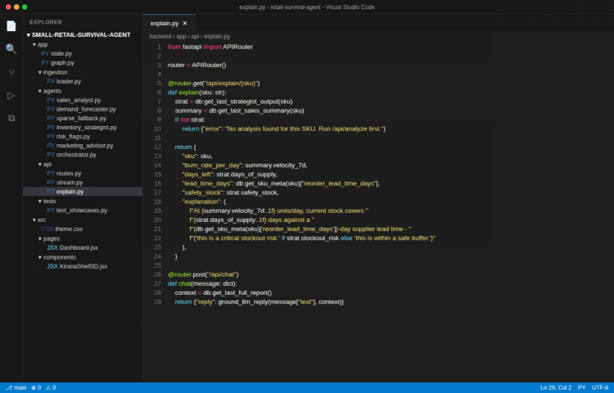
Description: The screenshot shows the /api/explain/{sku} handler building a grounded, numbers-backed explanation from previously stored agent output.

Milestone 6: Frontend Dashboard
This milestone delivers the React and Tailwind frontend in the dark Kirana visual language, including the 3D shelf visualization.

Activity 6.1: Dark Kirana Theme Setup
Define the background, panel, amber accent, and sage muted-text color tokens, and load the Fraunces headline and Inter body fonts.
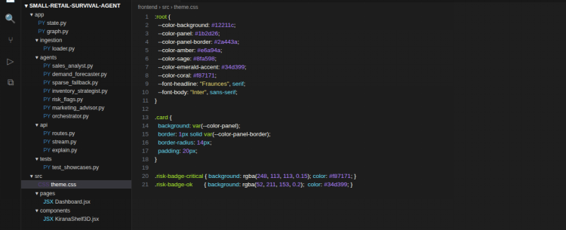
Description: The screenshot shows the CSS custom properties and card styling that implement the dark Kirana design language.

Activity 6.2: Executive Briefing Dashboard
Build the Monday Morning Action Briefing page: stockout and spoilage stat cards, and the risk ledger and marketing pick sections, fetched from /api/report/latest.
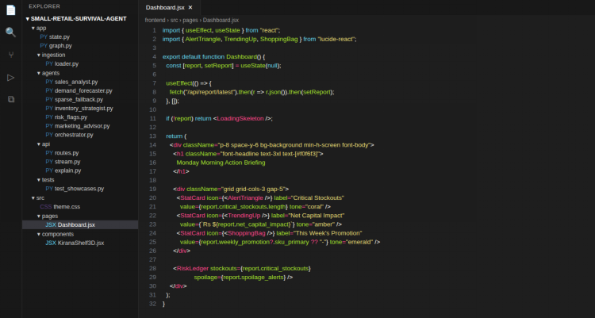
Description: The screenshot shows the Dashboard React component rendering the compiled executive report.

Activity 6.3: 3D Kirana Shelf and Live Stream
Render an animated Three.js shelf where box height reflects stock level and color reflects stockout risk, and build the live agent-stream view consuming the SSE endpoint.
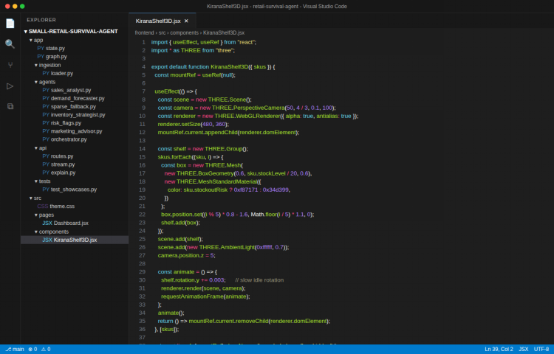
Description: The screenshot shows the Three.js component that builds the 3D Kirana shelf visualization from the SKU list.

Milestone 7: Testing, Documentation and Reporting
This milestone validates the 3 engineered showcase scenarios end to end and records the design rationale and future direction.

Activity 7.1: Showcase Scenario Validation
Automated tests confirm the 3 engineered scenarios in the synthetic 12-month, 50-SKU Kirana dataset all produce the expected agent outputs.
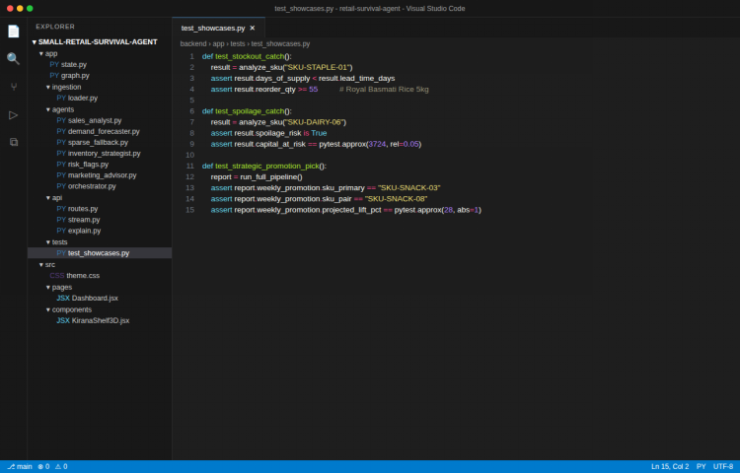

Scenario | SKU | Expected Result
Stockout Catch | Royal Basmati Rice 5kg | Days of supply (2.6) below lead time (7d); reorder ≥ 55 bags
Spoilage Catch | Artisanal Organic Paneer 200g | Spoilage risk flagged; ₹3,724 capital at risk
Strategic Promotion | Grand Reserve Masala Chai 250g | Selected as single weekly promotion, paired with Butter Biscuits, +28% lift

Activity 7.2: Design Decisions and Future Enhancements
• A single, focused weekly promotion (rather than a list) forces a high-conviction recommendation a shop owner can act on immediately.
• The Orchestrator's conflict veto keeps marketing from ever promoting a stockout-risk SKU.
• The sparse-data fallback lets new SKUs get a usable forecast from day one instead of requiring 8 weeks of history.
• The explainability path answers "why" questions from stored state, avoiding a costly pipeline re-run for every question.

Future Enhancements
• Connect a real POS integration for automatic daily CSV ingestion.
• Add multi-store comparison views for retailers with more than one location.
• Expand the Marketing Advisor to consider multi-week promotion calendars.
• Add authentication and per-store data isolation for production deployment.

Running the Application

Backend
cd backend
set GROQ_API_KEY=your_key (optional)
python run.py
The backend starts at http://127.0.0.1:8000 and seeds the SQLite database with 12 months of synthetic data on first run.

Frontend
cd frontend
npm install
npm run dev
The frontend dev server starts at http://localhost:5173.

Exploring the Website’s Web Pages:

Home Page:
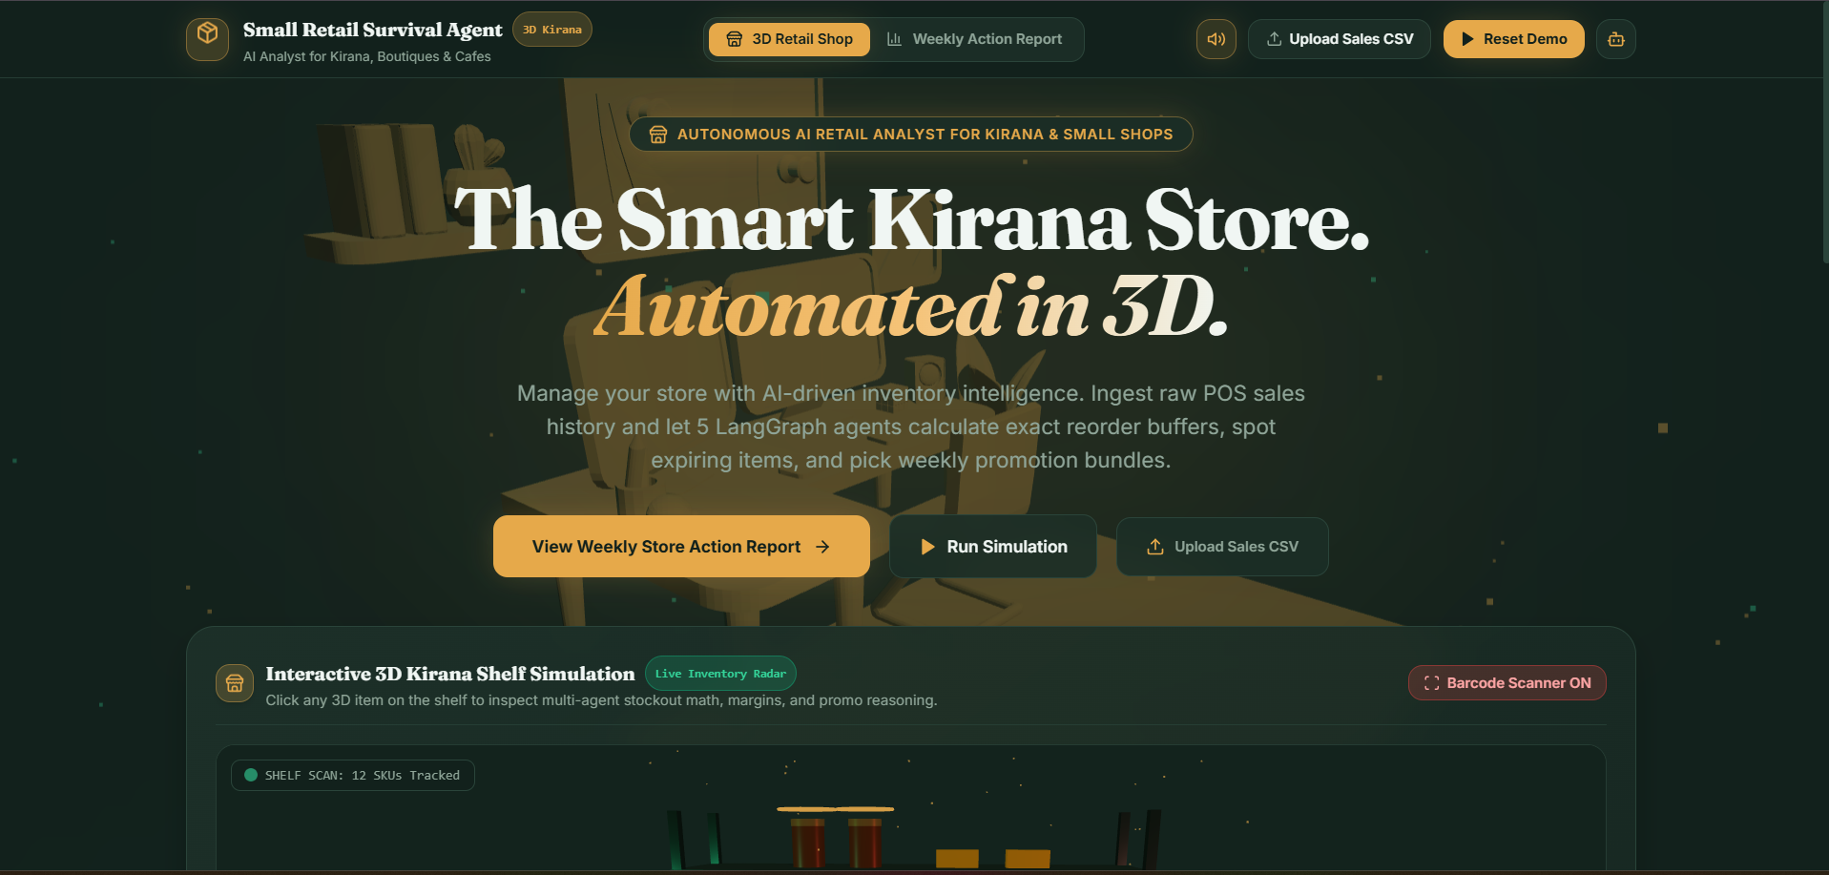
Description:The entry point of NexusAI. Users choose a persona (Admin, one of three mentors, or an intern) and enter the matching dashboard.
Upload / SKU Catalog:
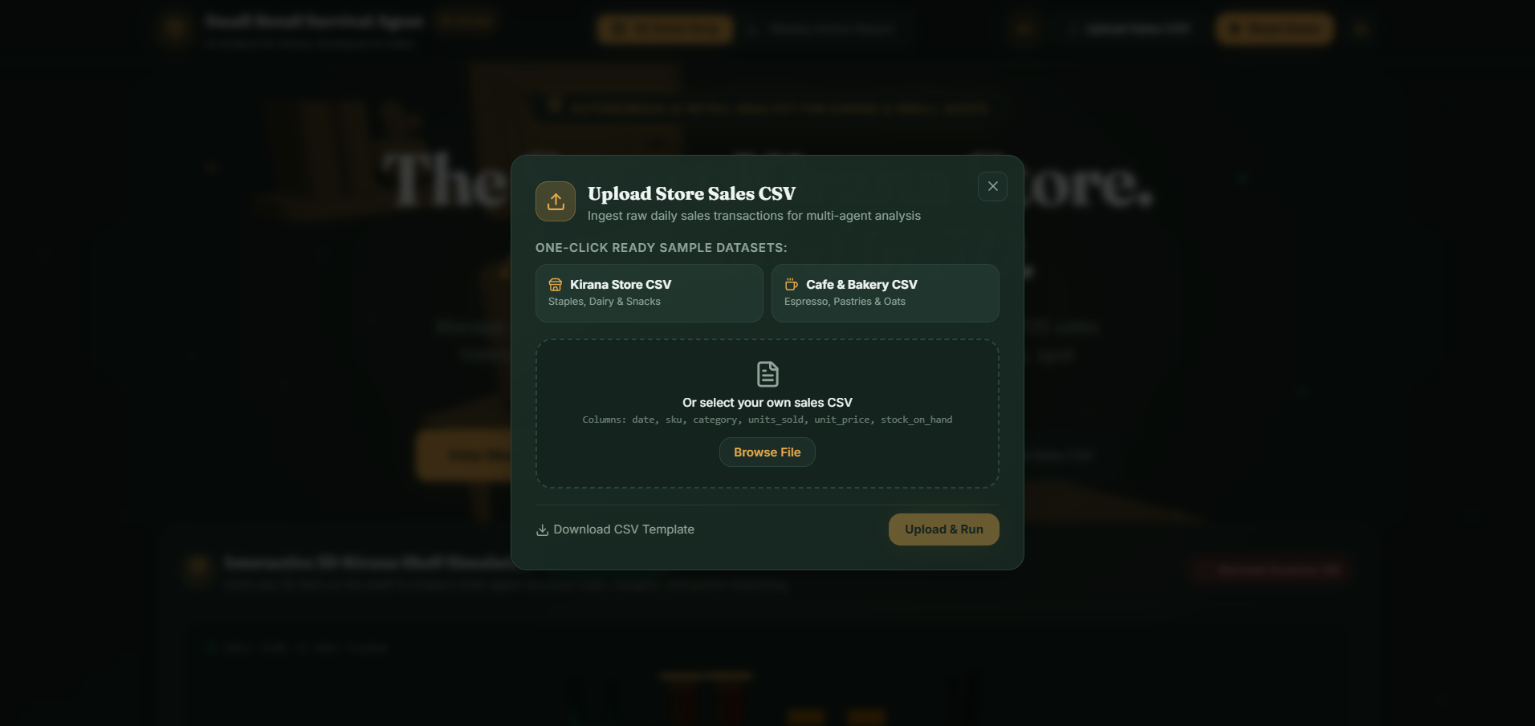
Description: Lets the shop owner drop a daily sales CSV or use the seeded synthetic dataset, and browse the current SKU catalog with stock and lead-time details.
Inventory Risk Ledger:
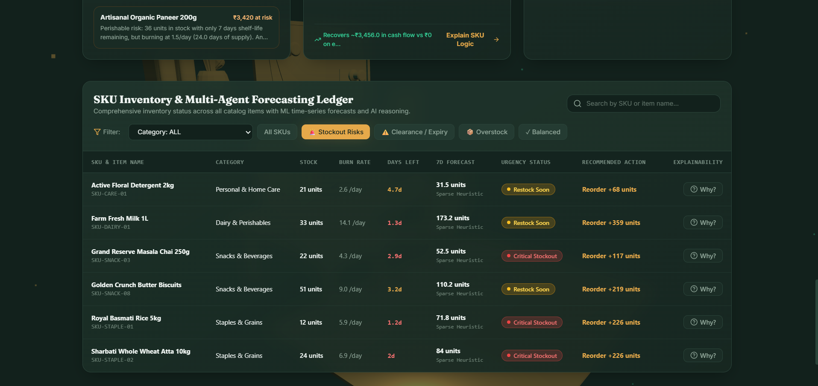
Description: Shows the status of every active project (ON TRACK, AT RISK, DELAYED, BLOCKED) and lets the mentor submit feedback that is stored in the Historical RAG space.

This Week's Single Promotion:
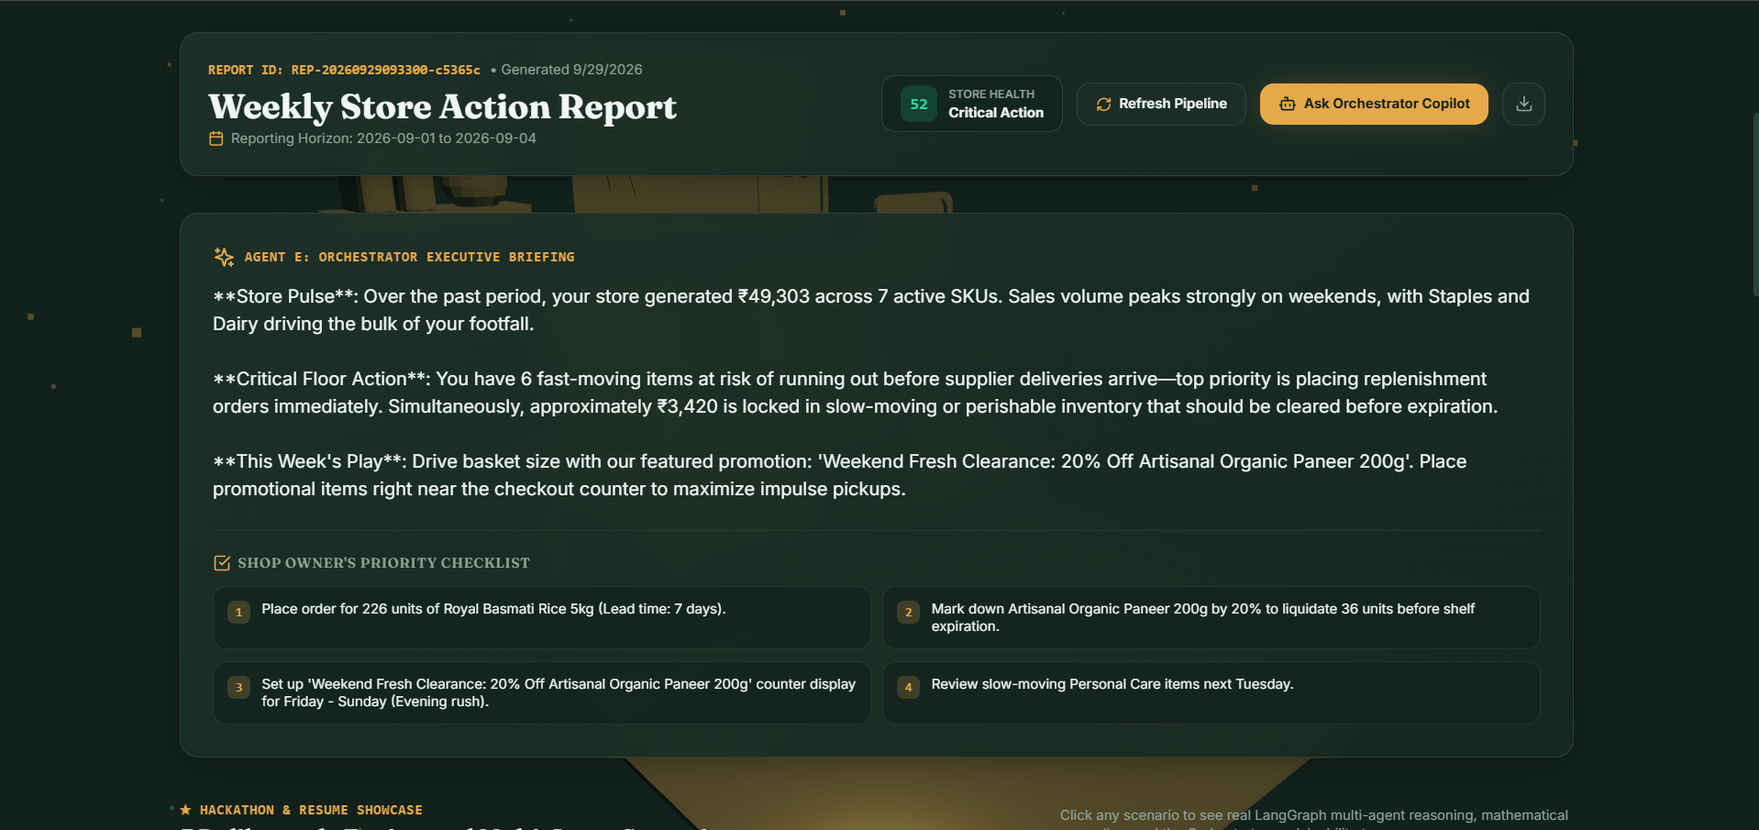
Description: Shows the one recommended promotional move with its projected lift and margin, and explains why other candidate SKUs were not chosen.

SKU Explainability:
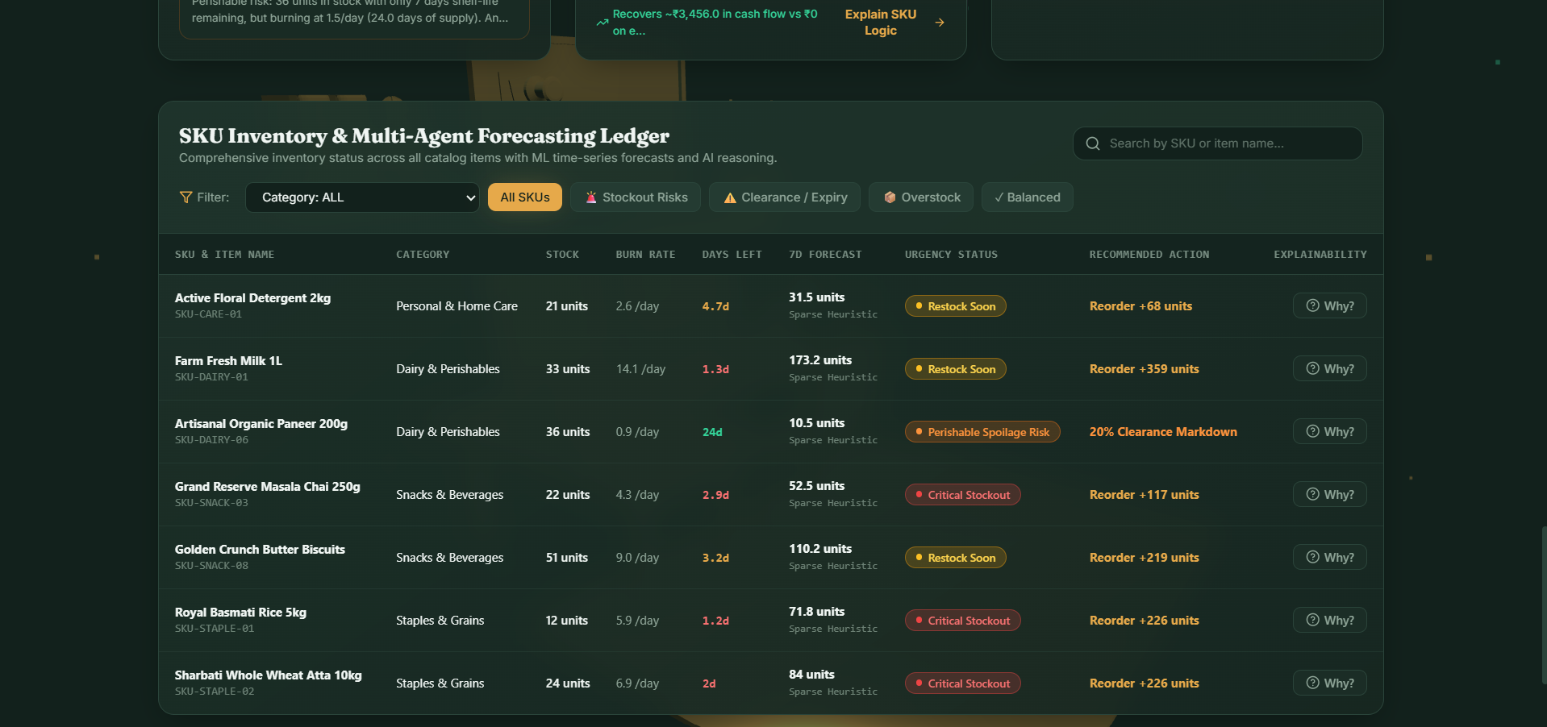
Description: Lets the shop owner ask "why" about any recommendation and get a grounded, numbers-backed answer instantly.

Conclusion
Small Retail Survival Agent shows how a small, well-scoped multi-agent system can replace the business-intelligence team an independent retailer cannot afford. Five LangGraph-orchestrated agents turn raw daily sales CSVs into a Monday-morning action briefing: a stockout catch that prevents an empty shelf, a spoilage catch that recovers working capital before it is lost, and a single, high-conviction weekly promotion. The Orchestrator's conflict resolution keeps the recommendations internally consistent, and the explainability path lets a shop owner trust the system by asking it "why" directly. The automatic sparse-data fallback means the system is useful from the first week a SKU is sold, not just after months of history accumulate. Future work includes real POS integration, multi-store support, and production-grade authentication.

